2018 MINI SITE COLLECTIONS: 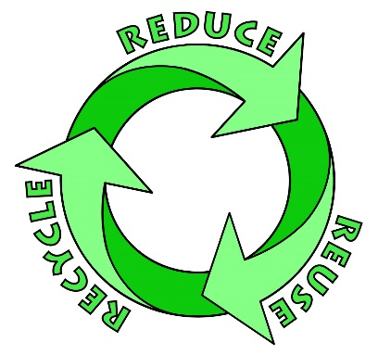
SATURDAY, JUNE 2ND - 8:30 - 10:30 am - LENOX DEPT. OF PUBLIC WORKS
275 Main Street, Route 7A, Across from Mass. Highway Dept.
WEDNESDAY, JUNE 20TH - 4:00 - 6:30 pm - GREAT BARRINGTON RECYCLING CENTER
PLEASE OBSERVE THE FOLLOWING:
ACCEPTABLE ITEMS: Used motor oil, oil-based paints, spray paint, turpentine, stains, thinners (no latex-water based).
UNACCEPTABLE ITEMS: Latex or water-based paint/stains, paint brushes/rags, medical waste, asbestos, fireworks & explosives, ammunition, gas cylinders, smoke detectors, radioactive material, fire extinguishers, empty aerosol cans, PCB's.
SPRING COLLECTION DAY FOR 2018:

light metals and Bulky Day – Saturday, May 26th, 10:00 AM – 2:00 PM – Highway Department Garage Area

Please Observe the following changes:

bulky waste bin:
Acceptable Bulky Items: Old furniture, rugs, scrap wood, etc.
PLEASE NOTE: We are unable to accept mattresses and box springs at no cost any longer. The Transfer Station is charging for disposal of those items. We will accept them at a charge of $25.00 per item.
Unacceptable Items: Tires, TV’s (Goodwill on Tyler St.), Glass, Hazardous Waste or Construction Materials, Toilets or any Porcelain products, Estate Clean-Outs. Trips will be monitored.

WHITE GOODS & LIGHT METALS BIN:
Light Metals: All items must be free of plastic or rubber grips or wheels, they must be empty of all contents (oil and fuel) from the motors and tanks. Aluminum doors and window frames must be free from glass. PLEASE NOTE: All refrigerators, freezers, air conditioners and dehumidifiers will be accepted with a $10.00 per item fee.

ELECTRONICS BIN:
For Disposal of: Monitors, printers, CPU’s, phones, batteries, copiers, scanners, modems, fax machines, laptops, radios, towers, speakers, servers, routers, ballasts, microwaves, cell phones, light fixtures, chargers, electrical equipment, battery-operated tools and printed circuit boards

